**SMART FASHION RECOMMENDER APPLICATION**

**PREPARE EMPATHY MAP**

TECHNICAL ARCHITECTURE:-

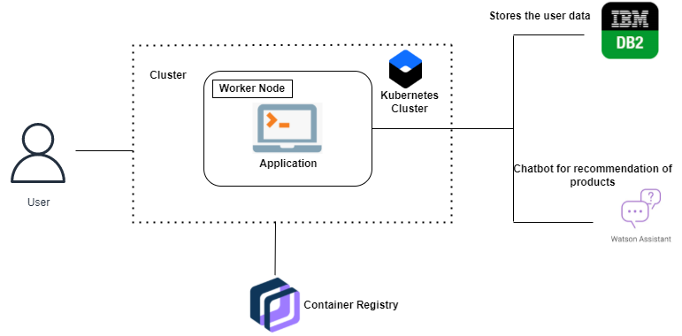

Fig 1: Architecture of Overall way of Processing Model

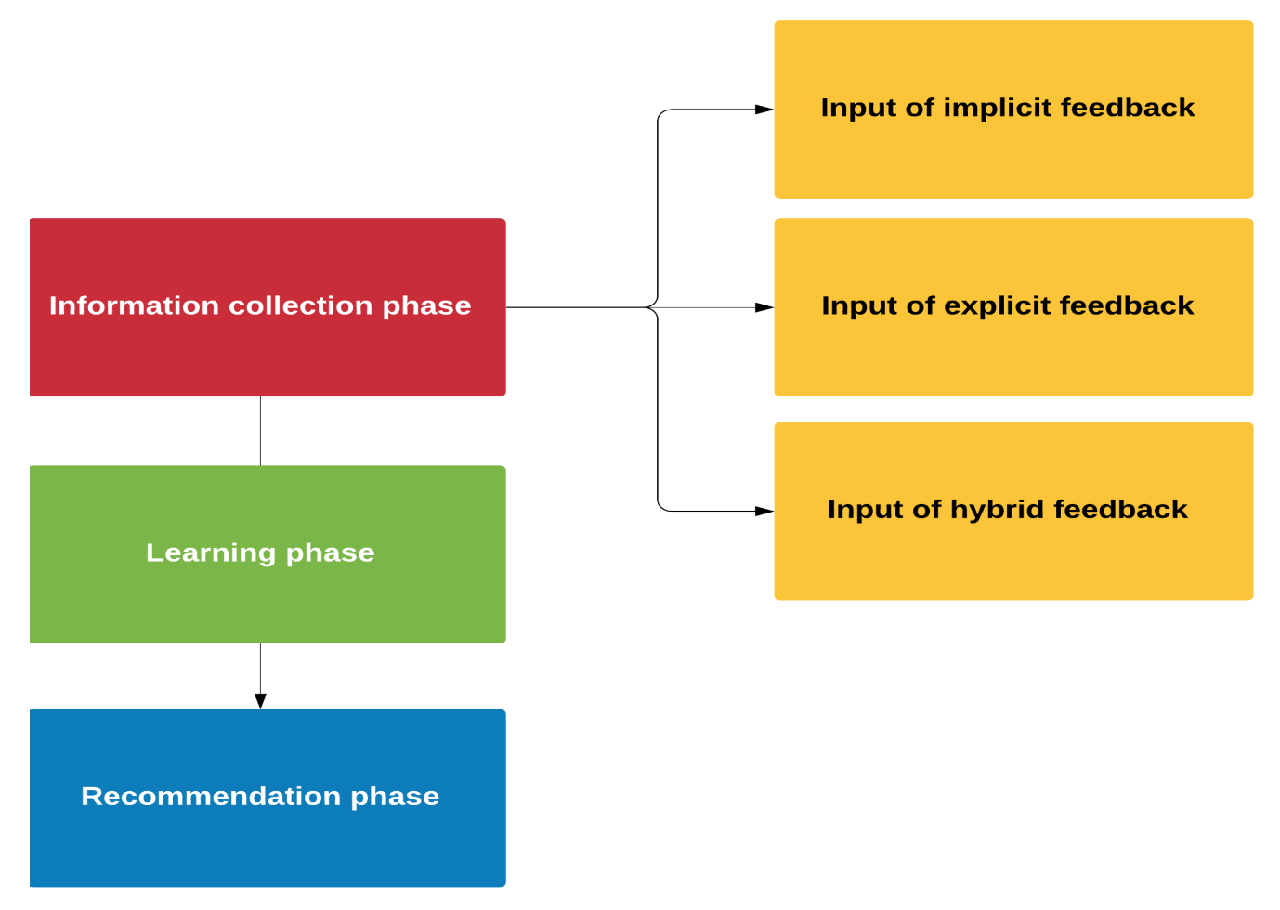

Fig 2 : Model and Method